The Friends’ association is a separate  charity, working to keep this Chapel open for everyone to enjoy - for music, arts, crafts, parties or meetings, or just to come in and admire. These activities also support the Churches Conservation Trust, the guardians of this redundant church.  The Chapel is still consecrated and there are a limited number of Services (and funerals from a restricted area) that still take place during the year, but it is no longer part of the parish churches in King’s Lynn, and is used mostly for community purposes especially art and music.  The Chapel is the largest building amongst the 350 English churches which are in the care of the Churches Conservation Trust. Its size compares with smaller cathedrals!  St Nicholas’ Chapel is a fine medieval building of national importance, because it still contains many architectural features of special interest and was almost wholly rebuilt in a short period around 1380 to 1410.  We encourage visitors and welcome the help of stewards to ‘keep the doors open’ and to show our history and architecture as part of the tourism sights of historic King’s Lynn.  We are a voice for all who help to manage this building, and we encourage new members with any appropriate skills or interest in welcoming the public to join us. | A large Heritage Lottery Fund (HLF) grant was made for restoration work in 2014-15.  The funding enabled  * the re-roofing of the chapel, conservation of woodwork, and internal repainting; and  *installing a kitchenette and toilet facilities allowing us to run more events;  We have developed new visitor information to allow the fascinating stories and history of the Chapel to live on for future generations, for families and expert visitors.  The brilliant acoustic of the Chapel has been used for many recording sessions, and there is an excellent organ (built by Willis & Son in 1899) to be enjoyed.  A further HLF grant was given in 2015, to the Friends for the restoration of the Bells. The peal of eight bells by John Taylor of Loughborough in 1869 is now in good condition for ringers eager to learn and experience their special tonal qualities.  The chairman of the Friends is Adrian Parker, who may be contacted through the website or tel: 01553 675574 | WHY NOT JOIN US?  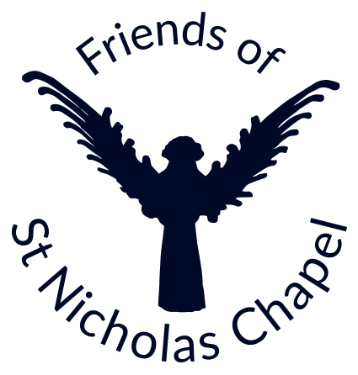  SEE OUR WEBSITE AT  www.stnicholaskingslynn.org.uk  Registered Charity no.1099693  Post to - FSNC, ‘Elmholme’, High Road, Magdalen, King’s Lynn PE34 3BQ
The Friends’ membership application form:
If you would like to become a Friend please complete this form and return it to:

The Treasurer, Friends of St Nicholas’ Chapel
‘Elmholme’, High Road, Magdalen,
King’s Lynn PE34 3BQ
(an SAE for a receipt would be appreciated)

Or email to: membership@stnicholaskingslynn.org.uk

Postal / Cash Subscriptions are payable on joining and on 1st June each year thereafter.
Members joining after 1st March, will receive membership for up to 15 months.
Direct Payments (Standing Orders/Direct Debits) can be made at any time.
Please complete in BLOCK CAPITALS.

Annual Subscription Rates - £7.50 per person / £12.00 couple (at same address)

I/We wish to re/join the Friends of St Nicholas’ Chapel, King’s Lynn, and -
* and/or I have completed a membership Standing Order (below) for this and future years ……….
I want to Gift Aid all subscriptions and donations that I make in the future or have made in the past 4 years
to The Friends of St Nicholas Chapel;

I am a UK taxpayer and understand that if I pay less Income Tax and/or Capital Gains Tax than the amount of Gift Aid claimed on all my donations in that tax year it is my responsibility to pay the difference. [Please notify the Friends if you want to cancel this declaration, change your address, or no longer pay sufficient tax to enable us to claim the refund.]
Gift Aid Signature…………………………………………………… Date…………………………
Name.......................…………………………………
Address..........................................……………………………………………………………………………………………………..
......................................................………………………….………………………………Postcode
Email: ……………………………………………………………
DATA PROTECTION
From time to time we may wish to send you directly information about the Friends, or the events and activities in the Chapel. This is the only quick and cost-effective way that the Friends can manage the task of keeping you in touch with social and arts events. Please allow us to use this method.
If you do not wish to receive any information about Friends/Chapel events, please tick this box. □

Bankers Order
To ............................................... Bank/Building Society
Address of your Branch ...............................................
…………………………………………………..……Postcode………………
Sort code.....................……………..……. Please pay to:
Your Account no.........…………………… Barclays Bank King’s Lynn Branch
Sort code 20-46-65 A/C No 60929530 for credit of: The Friends of St Nicholas’ Chapel, King’s Lynn
on the …….....(Day) of……..(Month) …….(Year) the sum of £..………... and the same sum on that date annually until further notice.

Full Name..........………………………………………… Signature ...........................................

